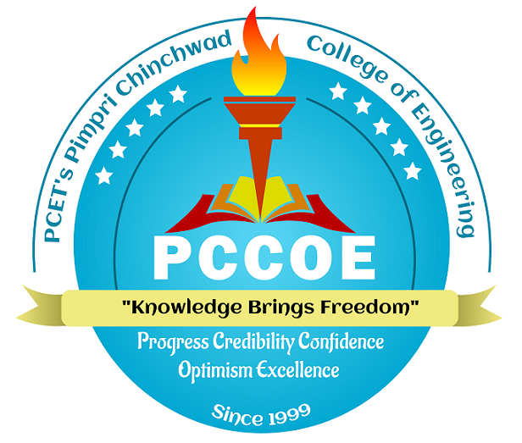 | Pimpri Chinchwad Education Trust’s  Pimpri Chinchwad College of Engineering (PCCoE)  (An Autonomous Institute)  Affiliated to Savitribai Phule Pune University (SPPU)

Advanced Data Science – Theory / Lab – AI -Tools Usage Disclosure Form

Department: MCA | Academic Year: 2026 – 2027 | Semester: I

Course Name | Advanced Data Science / Advanced Data Science Lab | Course Code | MCA33PE17 / MCA33PE21
Student Name | Manthan Sankpal | Roll No. / PRN | 125M1H064
Class / Division | S.Y. MCA | Date | 10th October 2026
Formative Assessments / Assignments Titles | FA-2 (BREAST CANCER DIAGNOSIS: Machine Learning Case Study)  FA-1 (Colored Pairplot)
Type (tick one) | - Formative Assessment (FA-1)  ☐ Formative Assessment (FA-2)  ☐ Practical / Lab Assignment  - Term Work / Other
1. Declaration of AI Tool Use
Tick the option that applies to this submission:
☐ No AI tool was used for this submission.
- AI tool(s) were used in an assistive role, as permitted by the Institute's AI Policy; details are disclosed below.
AI Tool Name | Purpose of Use | Prompt Summary (brief) | What Was Accepted / Modified by You
ChatGPT | Concept clarification and learning support for Data Science topics | Asked for explanations of Data Science concepts, Python implementations, and help understanding code. | Reviewed the explanations, tested relevant code, and adapted the material based on my own understanding.
Claude | Code assistance, concept understanding, and learning material refinement | Asked for help understanding Data Science topics, improving code, and organizing learning materials. | Evaluated the suggestions, reviewed the code, and modified the material to suit my learning objectives.
Example: ChatGPT | Concept clarification & grammar refinement | "Explain PCA in simple terms with an example" | Explanation was verified against the textbook and rewritten in my own words before use.

2. Reflection on Learning (2-3 sentences)
Briefly describe what you learned or verified yourself, and how the AI tool's role remained assistive rather than a substitute for your own understanding, skill, and effort.
I have used ChatGPT, and Claude as supplementary learning tools in order to clarify Advanced Data Science concepts, and also to understand Python implementations, and improve my learning materials as well. I reviewed the suggestions from them, practised the relevant concepts, and verified the code wherever applicable. The tools here supported my learning, while the understanding, verification, and final decisions remained my responsibility at last.
3. Student Declaration
I declare that the AI tool usage disclosed above is complete and accurate; that all citations/references used have been verified for accuracy (title, authors, year, and DOI/web link); and that this submission reflects my own understanding, reasoning, and effort, with AI used only in an assistive capacity as permitted under the PCCoE AI Policy in Academics.
Student Signature: | Date: 10th October 2026
Note: Undisclosed AI-generated text, paraphrasing, or translation presented as original work is treated as academic misconduct, per the Institute's AI Policy in Academics.

